Project Report
Title: YouTube Video Downloader

Submitted by: Samyak.J.Randive
Student Roll No: SY ECM 46
Student Enrollment ID: 2403111003
Submitted to: Dr. R. S. Khamitkar Sir
Department: Electronics and Computer Engineering
Date: 10.04.2026

1.Project Overview
The YouTube Downloader Pro is a Python-based web application developed using Streamlit that allows users to download videos or audio from YouTube. The application provides a simple and user-friendly interface where users can enter a YouTube URL, select the desired format (video or MP3), and choose the quality. The system processes the request and enables users to download the file directly to their system.
2.Problem Statement
With the increasing consumption of online video content, users often require offline access to videos for educational, entertainment, or personal use. However, many platforms do not provide direct download options. This project aims to develop an efficient and user-friendly application that allows users to download YouTube videos or audio in different formats and qualities without requiring technical knowledge.
3.Technology Stack
• Programming Language: Python 3.x
• Framework: Streamlit
• Library: yt-dlp (for downloading YouTube content)
• Library: imageio-ffmpeg (for audio/video processing)
• IDE: VS Code / Python IDLE
• Operating System: Windows/Linux

4.Implementation
The implementation of the project follows these steps:
- The user enters a YouTube URL into the input field.
- The application fetches video information such as title and thumbnail using yt-dlp.
- The user selects the download type (Video or Audio) and desired quality.
- The application processes the request and downloads the file using yt-dlp.
- If audio is selected, FFmpeg converts the file into MP3 format.
- A download button is provided for the user to save the file locally.
- A stop button is implemented to allow the user to cancel the download process.

5. Code Snippet
import streamlit as st
import yt_dlp
import os
import imageio_ffmpeg

st.set_page_config(page_title="YouTube Downloader Pro", page_icon="🎬")

st.title("🎬 YouTube Downloader Pro")

if "stop" not in st.session_state:
st.session_state.stop = False

url = st.text_input("🔗 Enter YouTube URL")
download_type = st.radio("Select Type", ["Video", "Audio (MP3)"])
quality = st.selectbox("Quality", ["1080p", "720p", "480p", "360p"])

col1, col2 = st.columns(2)

start = col1.button("🚀 Download")
stop_btn = col2.button("🛑 Stop")

st.caption("⚠️ Disclaimer: This can be only used for publicly available YouTube videos")

if stop_btn:
st.session_state.stop = True
st.warning("⛔ Stopping download...")

status = st.empty()

def progress_hook(d):
if st.session_state.stop:
raise Exception("Download stopped by user")

if d['status'] == 'downloading':
status.info(f"⬇ {d['_percent_str']} downloaded")
elif d['status'] == 'finished':
status.success("✅ Download finished, processing...")

if start:

st.session_state.stop = False

if not url:
st.warning("Enter URL first!")
st.stop()

try:
status.info("🔍 Getting video info...")

output_path = "downloads"
os.makedirs(output_path, exist_ok=True)

with yt_dlp.YoutubeDL({
'quiet': True,
'noplaylist': True
}) as ydl:
info = ydl.extract_info(url, download=False)

title = info.get("title", "video")
thumbnail = info.get("thumbnail")

if thumbnail:
st.image(thumbnail)

if download_type == "Video":
format_code = f"best[height<={quality[:-1]}]"
else:
format_code = "bestaudio/best"

ydl_opts = {
'outtmpl': os.path.join(output_path, '%(title)s.%(ext)s'),
'format': format_code,
'noplaylist': True,
'progress_hooks': [progress_hook], # important
'ffmpeg_location': imageio_ffmpeg.get_ffmpeg_exe(),
}

if download_type == "Audio (MP3)":
ydl_opts['postprocessors'] = [{
'key': 'FFmpegExtractAudio',
'preferredcodec': 'mp3',
}]

status.info("⬇ Downloading...")

with yt_dlp.YoutubeDL(ydl_opts) as ydl:
ydl.download([url])

if not st.session_state.stop:
status.success("✅ Download Complete!")

files = os.listdir(output_path)
latest_file = max(
[os.path.join(output_path, f) for f in files],
key=os.path.getctime
)

with open(latest_file, "rb") as f:
st.download_button(
"⬇ Download File",
f,
file_name=os.path.basename(latest_file)
)

except Exception as e:
if "stopped by user" in str(e):
status.warning("⛔ Download stopped successfully!")
else:
import traceback
st.error("❌ Error occurred")
st.code(traceback.format_exc())

6. Sample Test Cases
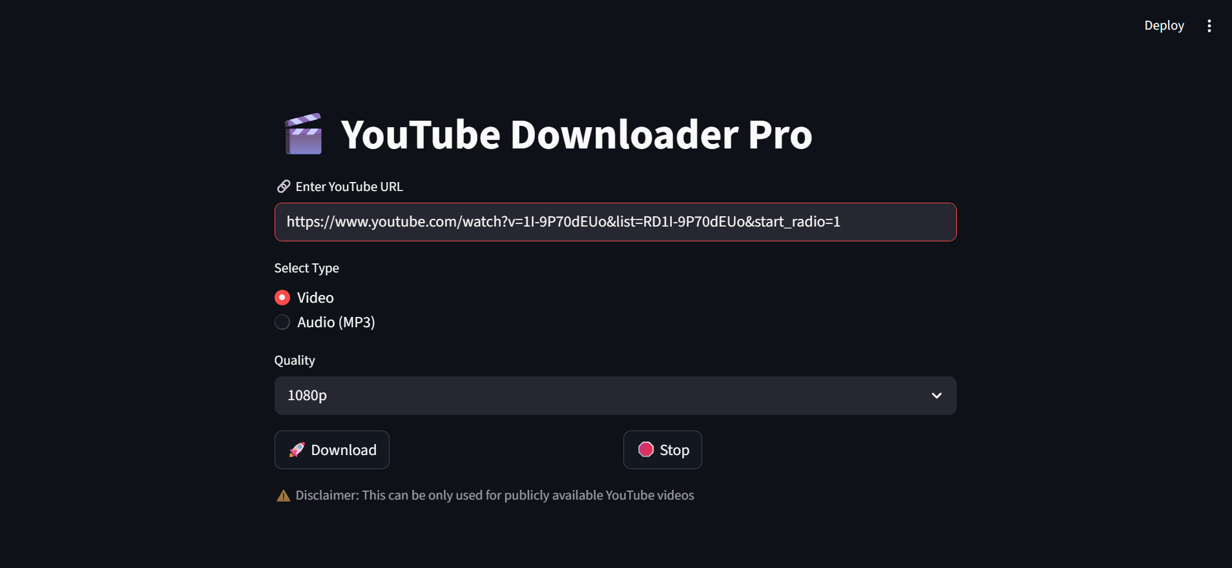

7.Challenges Faced
• Handling YouTube restrictions and blocking issues which caused delays in fetching video information.
• Managing playlist URLs, which sometimes caused the application to freeze.
• Implementing a stop download feature, as yt-dlp does not natively support cancellation.
• Ensuring proper integration of FFmpeg for audio conversion.
• Handling file naming issues and dynamically locating the downloaded file.

8.Results and Observations
The application successfully downloads YouTube videos and audio files in different formats and qualities. It provides a smooth and interactive user experience through Streamlit. The stop functionality improves usability by allowing users to cancel downloads. The system performs efficiently for individual video downloads and handles most edge cases effectively.

Project Submission
Repository Link: https://github.com/samyakrandive19/python_project

9. Signatures
Student Signature: ___________________________

Guide Signature: _____________________________

Date: ______________

